* we will write "npm run test" in the terminal.
* Then we will write "a" to run all the test.
  + 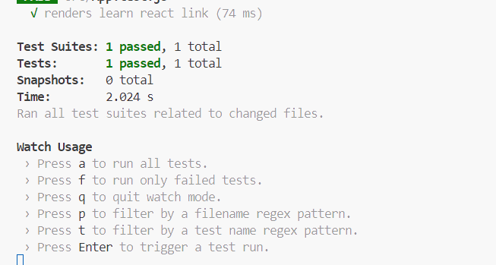
* Then it will run the App.test.js file:
  + 